Project: ‘Marmite Housing’  Respondent: Billy Ferrie  Year of Birth: 1960  Age: 65  Connection to project: Respondent  Date of Interview: 01/07/2025  Interviewer: Annette McGarill  Recording Agreement: Yes  Information & Consent: Yes  Photographic Images: Yes  Length of Interview: 27 minutes 47 seconds  Location of Interview: Respondent’s home, Calton, Glasgow  Recording Equipment: Zoom H4n (internal mics) |  |   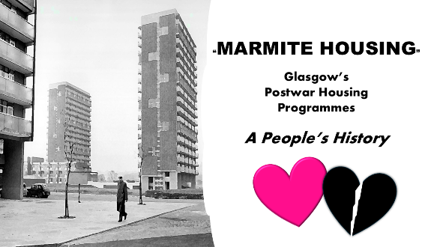
Time  (from: mins/secs) | Description |  | Transcribed Extract  (from- to:  mins/secs)
0.24 – 3.08 | Respondent talks about old tenement home.
 | “I remember out playing, the ashes and middens – amazing play space”  “I can remember the gas lights.” |  | 1.40 – 1.50  2.29-2.30
3.09 – 3.49 | Respondent talks about moving to Easterhouse.
 | “Moving to Paradise, more rooms and your own bathroom – green fields” |  | 2.55 – 3.25
3.50 – 4.21 | Impressions of new surroundings.  “Everything seemed big, spacious.” |  | 4.05 – 4.15
4.22 – 6.18 | Description of new flat/facilities/amenities.
6.19 – 7.51 | Respondent’s vivid memories e.g. of walks to lochs, fields, canals.
 | “skylarks singing – idyllic, rural almost” |  | 7.32 – 7.40
7.52 – 9.44 | Description of shops in the area, play parks, medical facilities etc.
9.45- 11.58 | Respondent talks about schools and education.
11.59 – 12.12 | Reference to lack of businesses/industry.
12.13 – 13.15 | Respondent talks about sense of community present.
 | “mentality of tenements remained – doors could be left open.” |  | 12.42 – 13.14
13.20-14.24 | Incidents of domestic violence and arguments remembered.
14.33 – 15.29 | Respondent recalls school outings to Calderpark Zoo and Lynn Park. Some pupils went on residential stays in summer holidays.
15.35 – 17.06 | Interview moves to post-school life – training, ambitions, going to Glasgow University and moving to West End.
17.07 – 18.12 | Parents’ jobs discussed. Industrial action taking place in country but not in local area.
18.19 – 19.10 | Respondent talks about current impressions of Easterhouse – changes in shopping, more retail facilities.
19.11 – 19.49 | Respondent reflects on fact that mentality and social issues remain. Attitudes the same.
19.52 – 20.36 | Respondent recalls Easterhouse Project and visit by Frankie Vaughan in response to gang culture which existed.
20.38 – 20.59 | Political attitudes discussed.
21.00 – 22.30 | Media attitudes to area are not respondent’s. He feels there is still a sense of humanity which is not portrayed –  “More focus is on negative aspects.”  “Resilience of local women not represented or appreciated.” |  | 21.48 – 22.05  22.15 – 22.30
22.36 – 23.16 | Respondent reflects on sense of identity in the area. Some echoes of past remain, such as sectarianism and resolving issues through violence. There is still a sense of community but less so. The vibe has changed.
22.36 – 23.16  23.17 – 24.19  24.20 – 25.29  25.30 – 27.47 | Respondent reflects on sense of identity in the area. Some echoes of past remain, such as sectarianism and resolving issues through violence. There is still a sense of community but less so. The vibe has changed.  Interview moves to possible changes/solutions. Respondent remarks that as styles of houses have changed to individual housing, there is less interaction. Opportunities are needed to allow interaction.  Respondent recalls experience of other areas in scheme where gang warfare meant certain places were to be avoided.  “places that wouldn’t be good to venture.”  Discussion of how housing scheme was idyllic at start, with lots of play opportunities, but changed with prevalence of gangs and drugs in 1970s.  “The whole environment became threatening /dark.”  “A toxic masculinity existed.”  “Glad to leave at end. – very oppressive” |  | 24.45 – 24.50  26.53 – 27.02  27.08 – 27.14  27.37 – 27.44
 | Interviewer thanks the respondent for his contribution to the project.

