Project: ‘Marmite Housing’  Respondent: Jack Millar  Year of Birth: 1949  Age: 76  Connection to project: Respondent  Date of Interview: 24/09/2025  Interviewer: Annette McGarill  Recording Agreement: Yes  Information & Consent: Yes  Photographic Images: N/A  Length of Interview: 45/56  Location of Interview: Interviewer’s home  Recording Equipment: Zoom H4n (internal mics) |  |   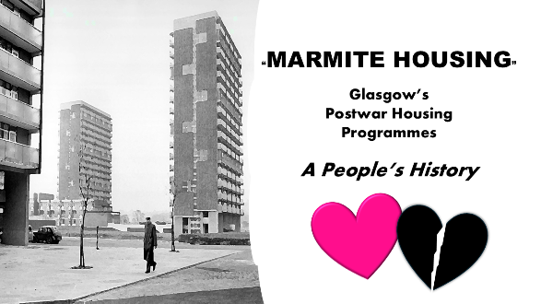
Time  (from: mins/secs) | Description |  | Transcribed Extract  (from 00.42- to: 45.50  mins/secs)
0.42 – 2.45 | Description of tenement flat – gas lighting and jawbox. |  | 3.15 – 3.21 “jawbox deep enough for a small child like me to be washed in”.
3.22 – 5.38 | Community discussed. Bustling, lots of shops. Local dairy paid respondent in crisps to pick up and deliver tins of crisps. |  | 4.38 –5.38 “I looked forward to that once a week”.
5.39 – 6.50 | Discussed education.
6.51 – 7.17 | Respondent talks about toys he played with – toy soldiers, marbles.
7.20 – 8.50 | Recollections of food eaten. |  | First carry-out food “mince and totties” from Lockwood’s Dairy
8.55 – 10.42 | Respondent recalls memories of holidays in Port Seton, Rothesay etc.
10.45 – 12.57 | Leisure activities. The Paragon Cinema discussed. |  | 12.10 – 12.56 “we had a cowboy with a horse – horse reared up and came off the stage…fun and games”
12.59 - 15.21 | Respondent recalls local employers, working life.
15.22 – 15.43 | Recollections of time there. |  | 15.30 – 15.43 “It was what you knew. We didn’t want for anything.”
15.45 – 18.05 | Discussion of new schemes. Respondent went to Castlemilk. |  | 17.29 - 18.04 “moved on back of flatbed coal lorry”.
18.06 – 19.11 | Respondent recalls first impressions of new area. |  | 19.08 – 19.10 “We thought it was great.”
19.12 – 21.32 | Description given of new house, then comparison with old tenement. |  | 20-05 – 20.41 “ out of nine houses in that close, I was related to five or six.”
21.33 – 23.54 | Respondent talks about balloting for new house and discusses gardens.
23.55 – 24.41 | Vivid memories from new house. |  | 23.58 –24.40 “two siblings being born in the house… the midwife coming.”
24.41 – 27.06 | Discussion moved to local amenities/ lack of these. Culture shock. |  | 26.32 – 26.37 “a pub on every corner”
27.14 – 28.03 | Respondent discusses his community. |  | 27.32 – 27.36  “I knew most of my neighbours by name”
28.06 – 28.39 | Post-school, working life and local employers discussed.
28.40 – 33.37 | Recollections of secondary school. After-school activities remembered.
33.40 – 34.27 | Adult leisure activities available. |  | 34.23 -34.27 “We weren’t short of places to go dancing.”
34.30 – 35.25 | Local industries/employers in Castlemilk at that time.
35.33 – 36.38 | Respondent’s perceptions of women’s working life.
36.40 – 38.02 | Changes to local community, issues remembered, e.g. gangs |  | 37.48 – 38.11 ”You couldn’t necessarily go to certain areas without putting yourself in danger.”
38.58 – 40.22 | Respondent discusses media perceptions of his area, and his current perceptions.
40.23 – 40.59 | Changes in community relations nowadays.
41.00 – 42.20 | Vivid memories of time in Castlemilk, and of being a ‘mod’.
42.21 – 44.38 | Respondent talks of other housing schemes in his youth.
44.41 – 45.50 | Respondent discusses other places he has lived compared to early-life areas. |  | 45.45 – 45.47 “I still feel that it’s home”.
 | Interviewer thanks the respondent very much for sharing his memories.





