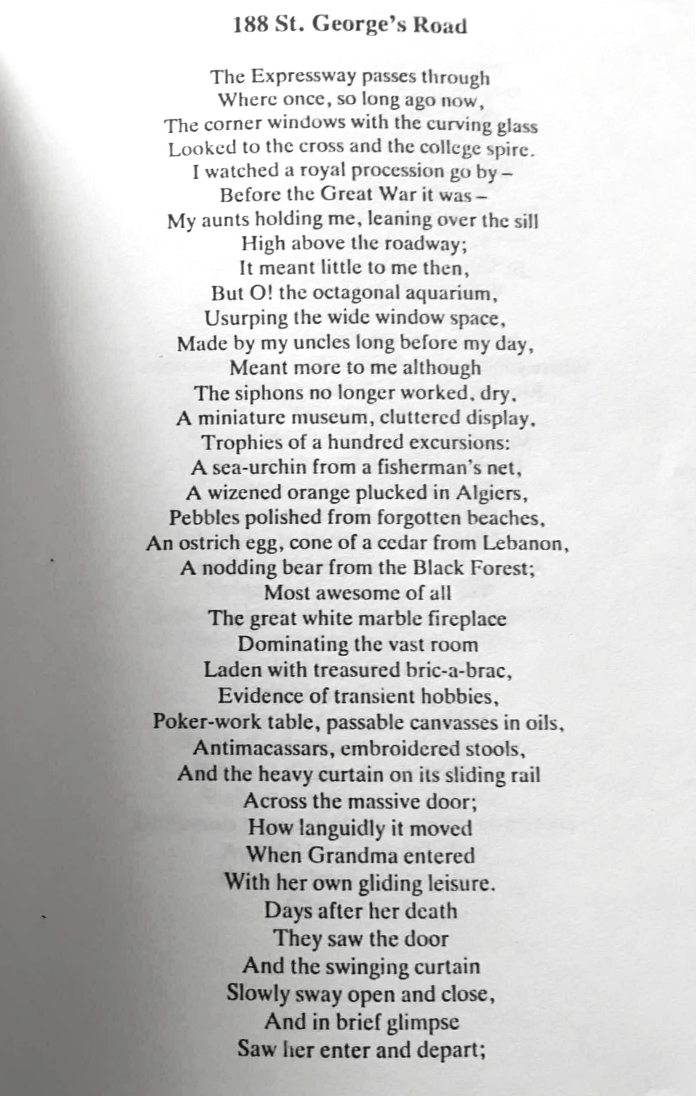

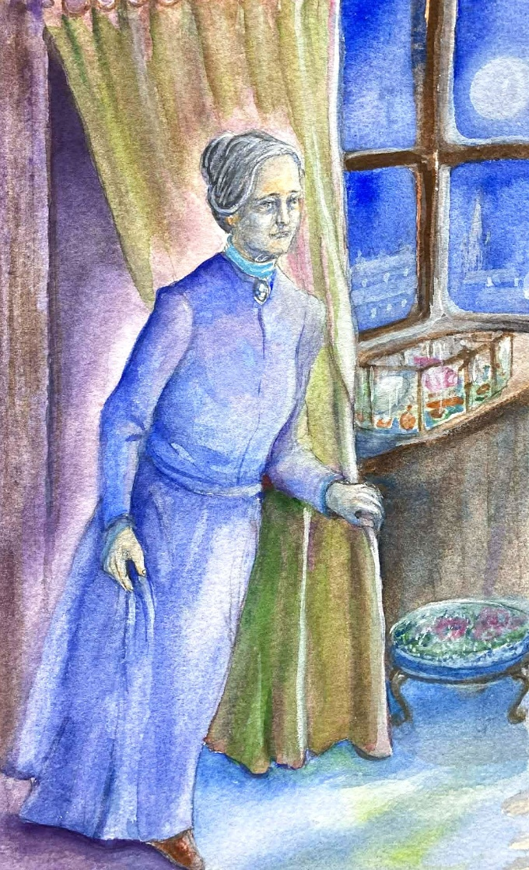
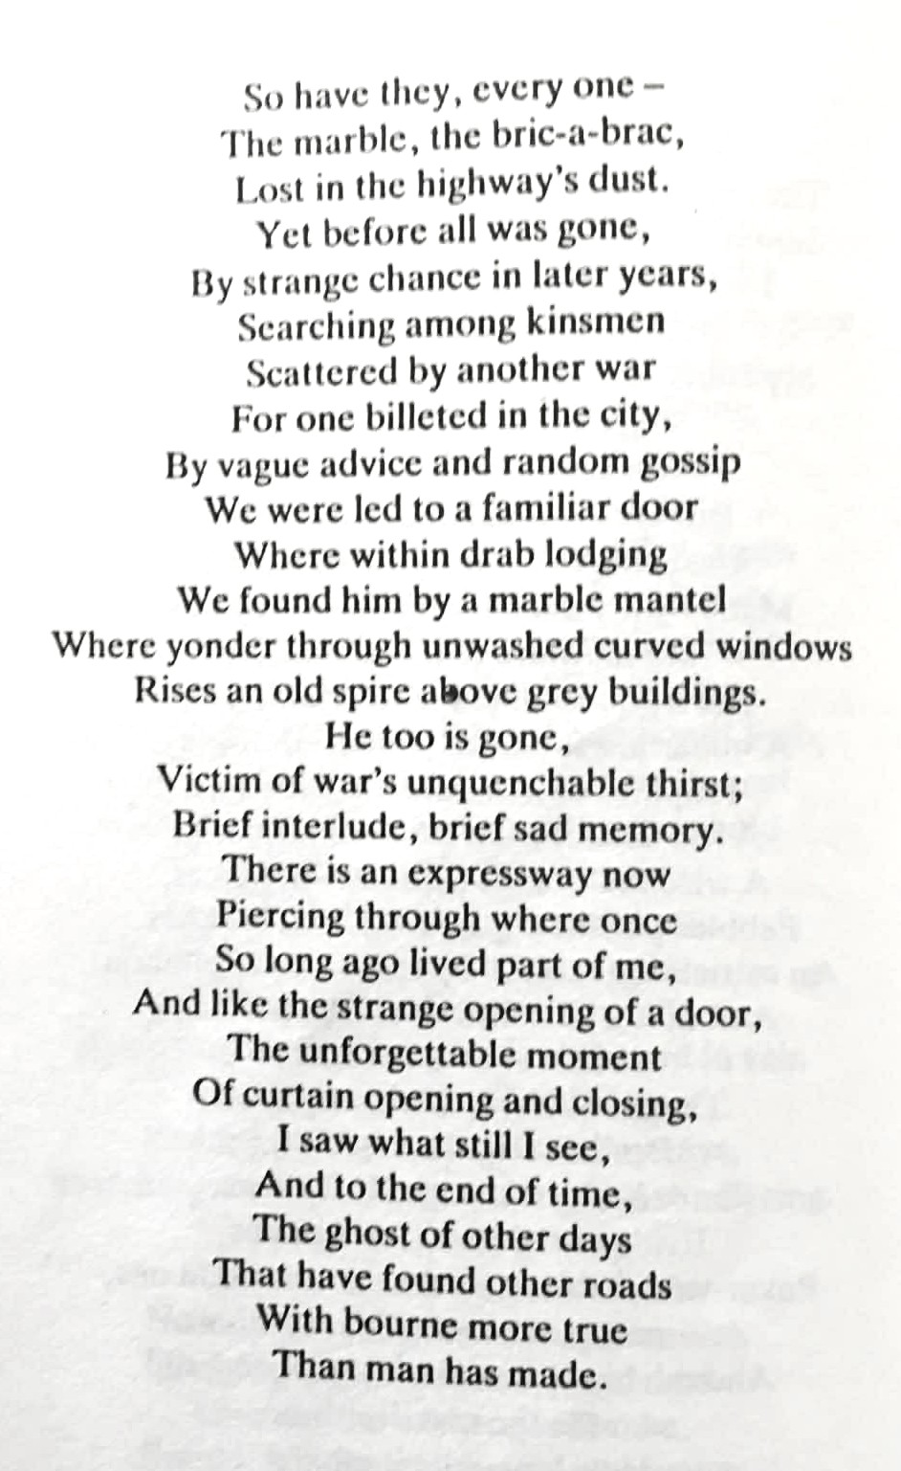
Written by Rev James T Runciman
Reproduced with permission from his family

Painting by Joyce Kelly
Reproduced with permission from her daughter, Rachel Kelly

