My Father, Pvt. Michael Kelly, Pioneer Corp, and Guard
at Cultybraggan POW Camp, Comrie, 1944
By Mike Kelly

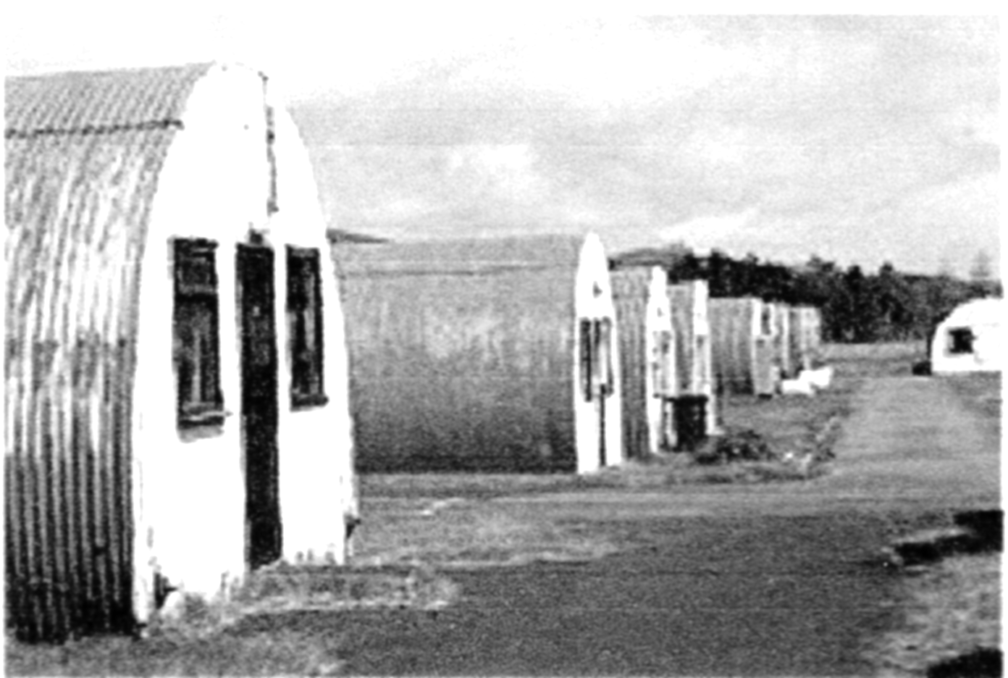
Cultybraggan Camp lies close to the village of Comrie, in west Perthshire. It was first used as a prisoner of war (PoW) camp during World War II and then became an Army training area. It later housed a Royal Observer Corps (ROC) nuclear monitoring post, and a Regional Government Headquarters (RGHQ).

Named PoW Camp No 21, built in 1941 to house 4,000 Category A prisoners, Cultybraggan was a 'black camp', holding those considered the most committed and fanatical Nazi PoWs, mainly young Waffen-SS; Fallschirmjager and U-boat crew, Army, Kriegsmarine, Air Force and SS prisoners were held in separate compounds, as were the officers. An additional camp was located at Cowden, two miles distant.

Ringleaders of the Devizes Plot - to break as many as 250,000 PoWs out of camps across the country in 1944 and attack Britain from within - were sent to Camp 21 at Comrie. These included Feldwebel Wolfgang Rosterg, a known anti-Nazi who was sent by mistake. He was lynched, and five of the prisoners were hanged at Pentonville Prison for his murder, the largest multiple execution in 20th-century Britain.

Amongst the prisoners was Heinrich Steinmeyer, soldier in the Waffen SS since 1942, who was captured in Normandy in August 1944. He died in 2014 and left a bequest of £384,000 to the village of Comrie, which was put into the Heinrich Steinmeyer Legacy Fund.

Private Michael Kelly - Pioneer Corps

Dad left Dublin in 1944 when he was 19 and traveled up to Belfast in Northern Ireland, which is part of the United Kingdom. Ireland was neutral during the 2nd World War, so he wanted to volunteer for the British Army. He went with his brother James. Dad was accepted but not as A1 due to his poor physical condition. James was rejected for the same reason and went back to Dublin. Dad went on by himself and did his army basic training near Conwy, Wales. He was then posted to Cultybraggan prisoner of war camp near the village of Comrie, Perthshire. He served there as a guard for the rest of the war. During this time, he and his mates would get weekend passes to Glasgow. It was there he met Mum at a dance hall, one night in 1945. He was de-mobbed (de-mobilised) or discharged from the army in early 1946.

We knew all this growing up and Dad would mention occasionally that the German POWs at the camp were the worst kind of Nazis. In 1987, I took Dad back to Comrie one afternoon. It was about a 45-mile drive from Rosyth into the Perthshire hills. We were both surprised to see that the camp was still there. It was being used as a weekend training facility for the reservists of the British Army's Highland Division.

No one was around that weekday, and a side gate was open. We went in and had a tour, and Dad said the old place had not changed at all. We stood outside of the Nissen Hut he said was his barracks. Back in town he pointed out the post box on the wall outside of the Post Office. He said that is where he posted his letters to Mum. Then we went for a pint in the Comrie pub and talked about his time there during the war.
