Project: ‘Marmite Housing’  Respondent: Hilary Hennessy  Year of Birth: 1964  Age: 61  Connection to project: Respondent  Date of Interview: 8 October 2025  Interviewer: Margaret Heraghty  Recording Agreement: Yes  Information & Consent: Yes  Photographic Images: No  Length of Interview: 30.22  Location of Interview: Clydebank Central Library  Recording Equipment: Zoom H4n (internal mics) |  |   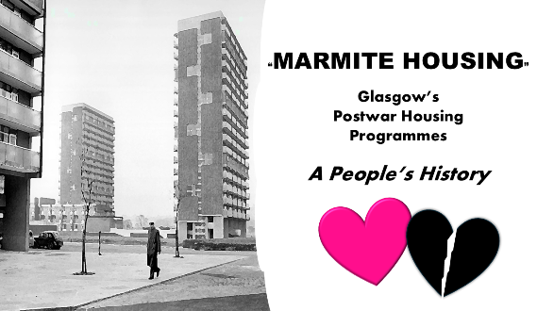
Time  (from: mins/secs) | Description |  | Transcribed Extract  (from- to:  mins/secs)
1.05-4.59 | Respondent speaks of memories of elderly grandparents’ moving, circa 1968, from a pre- war tenement in Dennistoun with a shared toilet and washing/drying facilities to a newly built high rise flat in Mount Florida with under floor heating and indoor plumbing. She recalled that her grandparents were not aware of exactly which flat they had been allocated until they arrived at the tower block, a memory confirmed from transcribing another tenant’s testimony, with the process known as ‘balloting’.
 | ‘We were at the bottom of the high-rise building. I was on my grandfather’s shoulders, and somebody just told him there and then what flat he was moving to’. |  | 2.52-2.59
5.00- 09.53 | She mentions memories of grandparents’ new flat as a home where the extended family met and she associated as a warm, happy place. She also speaks of the modern design and features which she later came to fully appreciate from her knowledge of housing design gained while working in housing allocation. Respondent continues on the layout of the flat which she believed was built to ‘Parker Morris standards’ and specifically the inclusion of ‘borrowed light’ in the form of glass panels at the top of door(s).
 | ‘What I do remember about the under floor heating was my gran used to heat her corset up. In the morning, so she’d get up, leave her corset from the night before under the rug, so when she put it on in the morning, it was nice and warm’. |  | 7.10-7.28
09.54- 13.05 | Respondent talks of the area surrounding her grandparents new flat and of the amenities available in the age before supermarkets. She recalls two characters, a local woman and the man who worked as caretaker in the block of flats where her grandparents lived.
 | ‘.. A woman I think my gran always tried to avoid. She would come down the road and always be halfway through a story by the time you met her and then you would get a bit of the story. She was always just in a rush. And years later when Billy Connolly was describing a character he said ’she always used to wear a Glasgow coat’ and when I think about this woman, she’d a Glasgow coat on’. |  | 10.55-11.15
13.06-17.10 | She talks about the place where her grandfather worked which was further away than her grandmother’s local employment, and of the relative isolation of the two blocks of flats surrounded by other housing types. Her grandparents lived in the flat for the rest of their lives.
 | ‘I think there was no identity perhaps within the two high-rise flats as an area within itself, but I think people there, because they would have used all the shops, possibly gone to work locally, they would have identified themselves with the Battlefield/Cathcart/ Mount Florida area so I think they would have been absorbed into that.’ |  | 16.20-16.43
18.01-19.46 | Respondent talks of other high- rise flats and other lower-rise and terraced buildings, erected on land previously owned by the family who owned Pollok House, close to where she lived and of the effect this had on the small school she attended.
 | ‘.. and when this estate was developed all of a sudden, our classes just hugely expanded from people moving in. Because, unlike where my grandparents lived, this was families which were being displaced. It was family housing that was being built so all these people came from all over Glasgow, I suppose.’ |  | 18.44-19.03
19.46-23.02 | Brief summary of the respondent’s work in housing management in England before her move to Glasgow. She then talks of the few years spent working for the council’s housing department, in the division dealing with anti-social behaviour, and the challenges that this presented.
23.02-24.45 | The respondents also recalls travelling for work on public transport in Glasgow and being able to revisit areas which she remembered from her childhood with her grandparents.
 | ‘It was in the east end of Glasgow and the reason why I particularly enjoyed it; one of the reasons, was that it kind of brought me full circle, because within the east area I covered was the area that my grandparents had come from. So quite often I passed, and this is the interesting thing, I passed the road that they’d lived in. So, they moved out in 1968 and it was in 2023 that I first started to work there and that road hadn’t been rebuilt’. |  | 23.08-23.35
24.46-28.10 | Respondent talks about the differences in the field of housing over the course of her career with less social housing. Also, of the difference in the types of tenants and a greater awareness of their rights.
 | ‘ I suppose in more recent times, probably, more recent, five years or so, due to social media people are more aware of their rights within housing as well. So there’s been a lot of work done around damp and mould because there was a young boy in England who died in social housing… in Rochdale so that’s led to a change in the law in England and it’s just about to change in Scotland as well about standards around damp and mould’. |  | 27.11-27.45
28.10-30.15 | Respondent speaks of post-war housing as being enduringly popular, as evidenced by the number of people who continue to live in the area where they, or where their parents before them, were originally allocated housing.
 | ‘So, I suppose the project title is about Marmite housing but, actually for a lot of people, they love it because that’s where they have chosen to stay and their families have continued to stay there. So I think, when you think about media portrayal maybe it’s ‘people don’t like postwar housing’ or the stereotype is that it’s all bad. But if you go and work there or speak to the people there they love it. Or, I am not saying they all love it, but most people do and are pleased to live there. And their kids continue to stay there even if they move out to buy their own house. It’s in the estates that are near where they grew up’. |  | 29.00-29.36
30.16-30.22 | Thanks to the respondent and closure of the interview.





